

Aldenham School

IGCSE Biology – Practical Requirements
Amended 02/2013

Specificatio

Triple Award – All Sections

Double Award– Omit Blue BOLD Sections

This booklet outlines the common principles involved in carrying out practical investigations and summarises the practicals.

Your ability to apply the principles to these practicals will be tested in the Both Paper 1 and 2.

Introduction

In both papers, you may be asked to recall and/or describe practicals you have covered within the course and which are summarised within this document. When putting together practical-based questions, the examiners will have assumed that you are familiar with the processes involved. These are detailed in the back of your textbook in Appendix A on pages 247 – 254. Generally, an investigation will be made up of 4 stages summarised as follows:

- Planning experimental procedures (CORMS)
- Obtaining Evidence describing techniques and taking measurements
- Analysis of evidence, drawing conclusion based on scientific knowledge and understanding AND communicating findings using calculations, tables and graphs
- Evaluation identifying sources of error and inaccuracy and suggesting improvements and extensions to investigations

There are expected techniques you should use when answering exam questions relating to experiments.
Planning
You may be asked to describe an investigation in the exam. These questions are usually worth 6
marks.

You must use CORMS to answer your question.

C – Change & Compare. State what you are changing (DISTANCE, HEIGHT, TIME, TEMPERATURE, LIGHT INTENSITY, OUTDOOR / INDOOR) always! E.g. before / after, with / without. If possible, give a range of specific values, E.g. 15, 20, 25, 30, 35ºC.

O – Organism. You need to decide what organism you are going to study and whether you are going to use more than one individual, of the same sex, age, health etc.

R – Repeat. The experiment should be repeated 3 times. A mean can be taken of the 3 results to give a more reliable result.

M – Measure. What you measure and how you measure it needs to be stated. How long you are going to measure for in time, the measuring device and the units of measurement should ALWAYS be stated. I am going to measure the distance with a ruler, time with a stopcock, temperature with a thermometer etc

S – Same. State the variables that should kept the same. E.g. specified concentrations, volumes, times, age, sex etc.

Example: Describe an experiment you could do to find out the effect of pH on the growth of yeast.

C- I would use different PHs 2, 4,6, 10, 12 and a control with water
O- I would use the same species of yeast at the same age (2 days)
R- I would repeat the experiment three times
M- I would measure the growth of yeast by collecting CO2 in a measuring cylinder in ml for 10 minutes
OR I would count the bubbles produced by yeast for 10 minutes
OR I would count the number of yeast using a microscope.
S – I would keep the temperature the same, the mass of yeast in grams, the species and growth phase of yeast etc
Obtaining Evidence

Of most importance is that you can draw up a table of results:
- Neatly – with a pencil & ruler
- With headings and correct units set out appropriately
- Recording results accurately.

Analysing

- Analysis may start with some calculations based on your results, or an appropriate graph showing trends.
- You should be able to describe what the results show e.g. describe to a bind person what is happening in the graph, USE NUMNERS AND UNITS
- Now you must use your detailed biological knowledge to explain the results. This may be a repeat what you wrote in your prediction.
- If your actual results are different from your predicted results, you should attempt to explain why.

Evaluation

- Not all experiments work out as expected, and for good reasons.
- If anomalies are apparent, identify and quote them.
- Identify also aspects of the experiment which would have led to inaccuracies and difficulties in obtaining reliable and precise results. These are called limitations and will be sources of error.
- You should then suggest ways of making improvements to improve the experiment in the future – one example for each of the limitations you have cited.
- Finally, you should be able to describe how you might extend this investigation to provide additional relevant evidence.
Checklist of required practical work and investigations

• describe the tests for glucose, starch, lipid and protein (p43)

Φοοδ | Ρεαγεντ | Τεστ Ποσιτιϖε | Τεστ Νεγατιϖε
Γλυχοσε | - Ηεατ ωιτη  - Βενεδιχτ’σ | Βριχκ Ρεδ | Σταψσ Βλυε
Σταρχη | - Αδδ Ιοδινε | Βλυε / Βλαχκ | Ορανγε / Βροων
Λιπιδ | - Σηακε ωιτη ετηανολ  - Πουρ ιντο τεστ τυβε οφ χολδ ωατερ | Ωηιτε χλουδψ λαψερ ον τοπ | Νο εμυλσιον φορμεδ
Προτειν | - Αδδ Βιυρετ ρεαγεντ | Μαυϖε / Λιλαχ | Σταψσ βλυε

• describe how to carry out simple controlled experiments to illustrate how enzyme activity can be affected by changes in temperature. (pp5&6)

Effect of temperature – typical plan

e.g. amylase with starch (broken down to maltose & glucose)

- Temperature range – 0 – 100°C, 10°C intervals
- Same volumes amylase & starch
- Same concentrations of starch and amylase
- Bring to temperature before mixing together
- Kept at constant temperature – thermostatically controlled water bath
- Sample every minute
- 1 drop of mixture + 1 drop iodine
- Time taken for blue/black colour to disappear
- Repeat twice more, take mean
- Plot graph

or catalase with hydrogen peroxide (broken down to water & oxygen)

- as above but with potato slices
- same number of slices
- same volume & concentration of hydrogen peroxide
- measure volume of oxygen evolved
- by displacement in upturned burette

• describe simple experiments on diffusion and osmosis using living and non-living systems. (pp10&11) (pp126-128)
Diffusion
a.
- Cubes of agar containing pH indicator
- Cut up into different shapes / sizes
- Put into dilute acid
- Time taken to change colour noted
b.
- Ammonium hydroxide gas (an alkali) travelling in a tube
- Pieces of red litmus placed at set distances (10cm) along tube
- Time taken for each piece of litmus to turn blue recorded
- Comparing different concentrations of ammonium hydroxide

Osmosis (Linked to water potential)
a.
- Visking tubing (dialysis tubing) tied at one end
- Filled with sucrose solution
- Other end attached to a capillary tube
- The level of the sucrose can be noted before and after
- Tubing has been placed in a beaker of water for about thirty minutes.
b.
- Onion epidermis
- Cut into squares and mounted on slides
- In different concentrations of sucrose solution
- Observing under a microscope
- Shows the effects of osmosis – turgor, plasmolysis, flaccidity.
c.
- Red blood cells
- Mounted on slides
- In hypotonic, isotonic and hypertonic saline
- Observing under a microscope
- Shows the effects of osmosis – bursting, shrinking.

Potato Chip Experiment
- Potato slices/chips of fixed dimensions (cork borer)
- Mass recorded before
- Placed into solution of varying water potential (saline solution)
- Left for 60 minutes
- Dried
- Massed again
- Several chips done for each solution
- % change in mass calculated
- Means calculated
- Graph drawn
- Isotonic point determined

Can modify observing change in length or change size (SA:Vol Ratio)
• describe simple controlled experiments to investigate photosynthesis, showing the evolution of oxygen from a water plant, the production of starch and the requirements of light, carbon dioxide and chlorophyll. (pp110-112, pp116)

water plant
inverted funnel
water
thermometer
boiling tube
gas collecting in
tube
lamp

- Place a water plant (Elodea or similar) in a beaker of water
- Cut stem under water
- Cover with a glass funnel which has a water-filled test tube placed over its opening
- Shine light from one side at a known distance (e.g. 30cm) from plant
- Allow plant to equilibrate for 3 minutes
- Count number of bubbles (of oxygen) given off
- In 3 consecutive 5 minute periods
- Test gas to prove it’s oxygen
- Repeat 5 more times at different distances (25,20,15,10,5 cm)
- Take means and plot Rate against distance (light intensity)

Other variables include:
- colour/wavelength of light (coloured filters are placed between the plant and the light source);
- carbon dioxide availability (the plant is immersed in solutions of different concentration of sodium hydrogen carbonate).

To test leaves for starch

- put into very hot/boiling water for one minute (to destroy the cell membranes so that chlorophyll molecules can pass through)
- put into hot ethanol (to remove/dissolve the green chlorophyll)
- put leaf into water (to rehydrate and soften leaf so that it can be spread out)
- put iodine solution onto the leaf – blue-black colour will show the presence of starch.

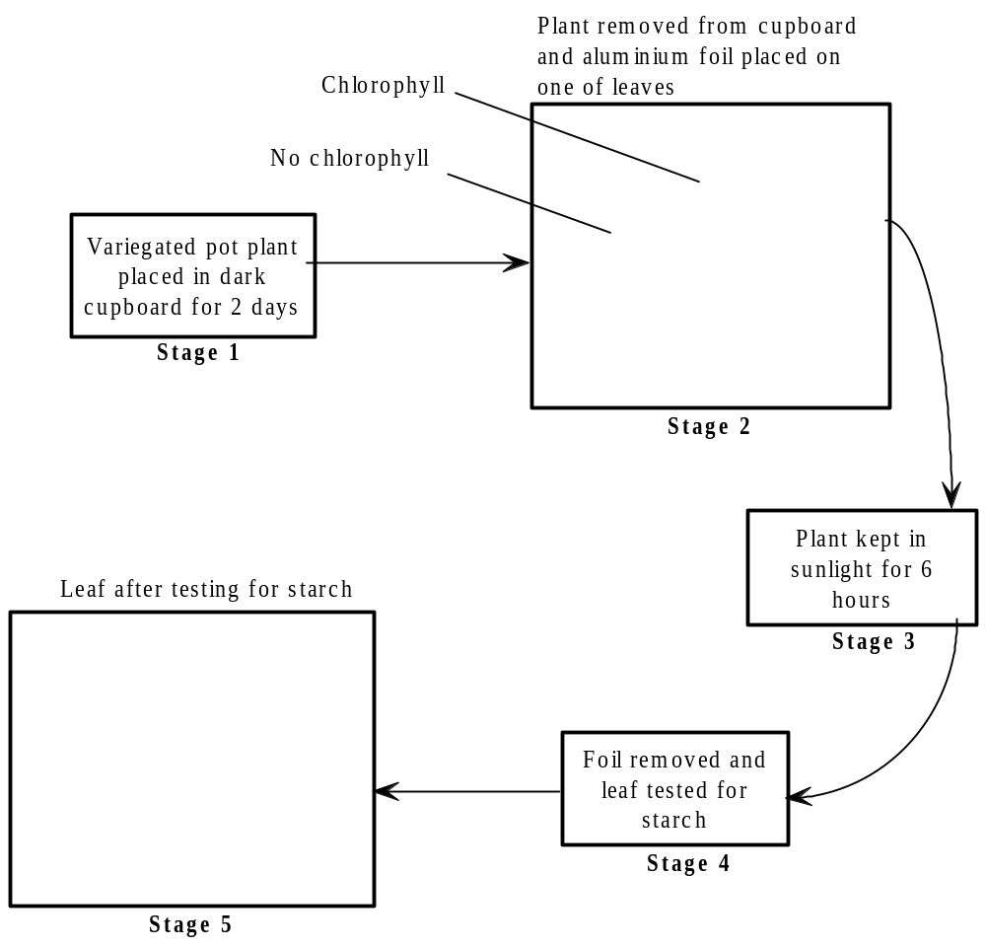
aluminium foil
A
B
C

To investigate photosynthesis, showing the production of starch by leaves and the requirements for light, carbon dioxide and chlorophyll

- Starch production can be investigated by placing a plant in the dark for 24 hours to destarch the leaves.
- A starch test on a leaf will not give a blue-black colour, whereas a similar test on a control leaf from a plant kept in the light will give a blue-black colour.
- A starch test on a variegated leaf can be used to demonstrate that chlorophyll is needed for photosynthesis.
- To show that carbon dioxide is needed for photosynthesis, a leaf on a plant may be surrounded by air with no carbon dioxide by inserting it into a conical flask containing a small amount of potassium or sodium hydroxide.
- The plant is left in good light for 24 hours.
- The test leaf and a control leaf from the plant are then tested for starch.
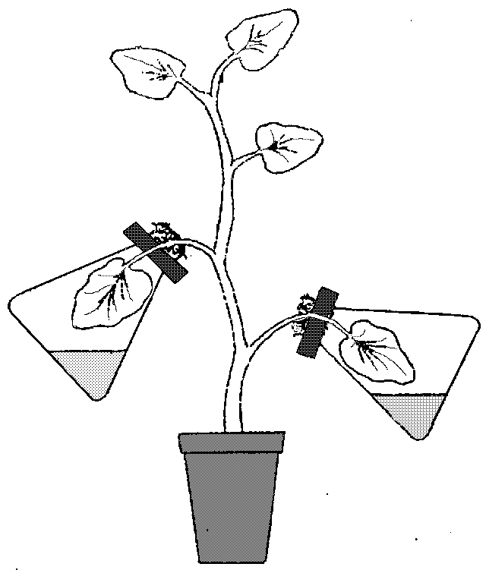

• recall how to carry out a simple experiment to determine the energy content in a food sample. (pp45)
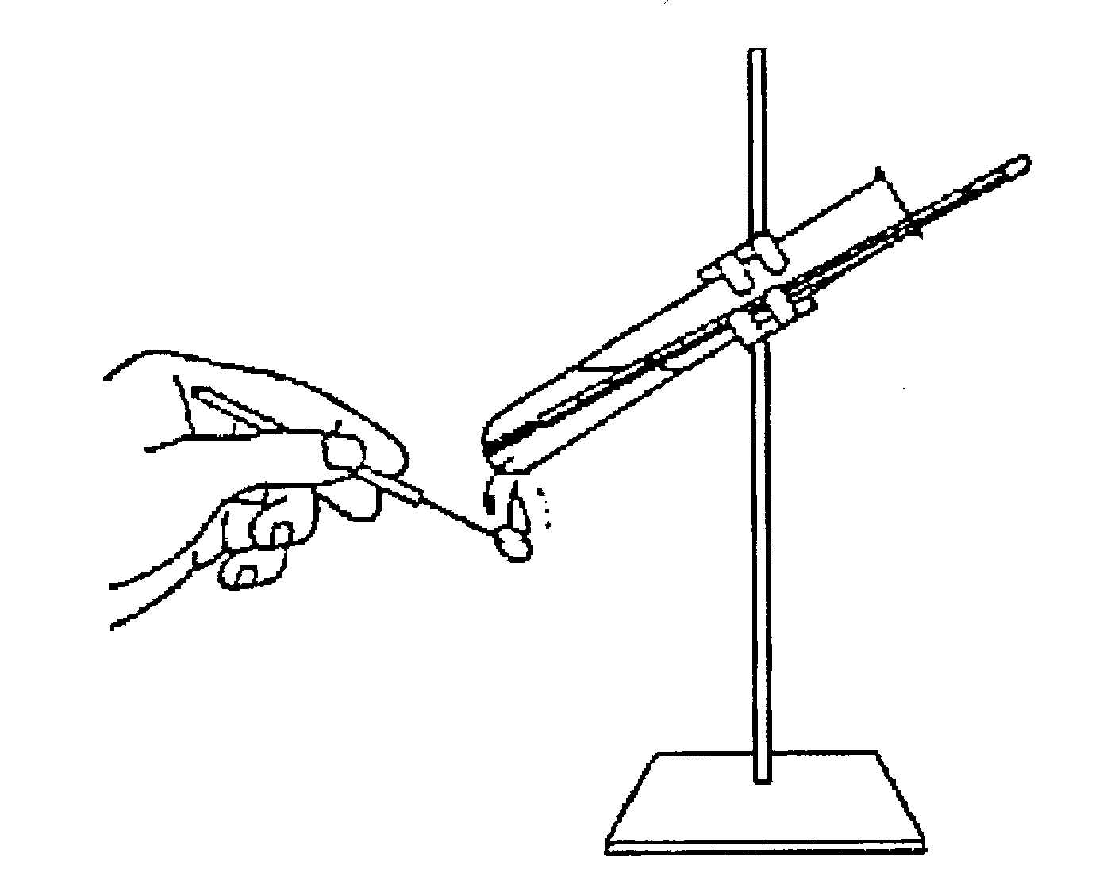
- Using a food calorimeter
- Known mass of food (g)
- Set volume of water (e.g. 20cm³)
- Take initial temperature
- Ignite food and heat boiling tube of water till food no longer burns
- Take final temperature
- Energy (joules/gram) = Temperature Difference x 20 X 4.2
Mass of Food
- Note: very inefficient. Lots of energy losses. Where?

• describe simple controlled experiments to demonstrate the evolution of carbon dioxide and heat from respiring seeds or other suitable living organisms. (pp8&9)

Controlled experiments to demonstrate the evolution of carbon dioxide and heat from respiring seeds or other suitable living organisms

- Live seeds (peas) compared to boiled dead seeds (control)
- Wash both sets of seeds in disinfectant to kill microbes (why?)
- Placed in (inverted) vacuum flask insulates from changes in external environmental conditions (hot air rises)
- Cotton wool plug lets O₂ in, CO₂ out
- Thermometer inserted to record temperature at start & finish
- A glass tube runs from inside the flask, through the bung and into an indicator solution of either limewater or hydrogen carbonate. The carbon dioxide produced changes the colour of the indicator solution.
- To show heat production the flask needs a cotton wool bung with a thermometer going through the bung into the flask.
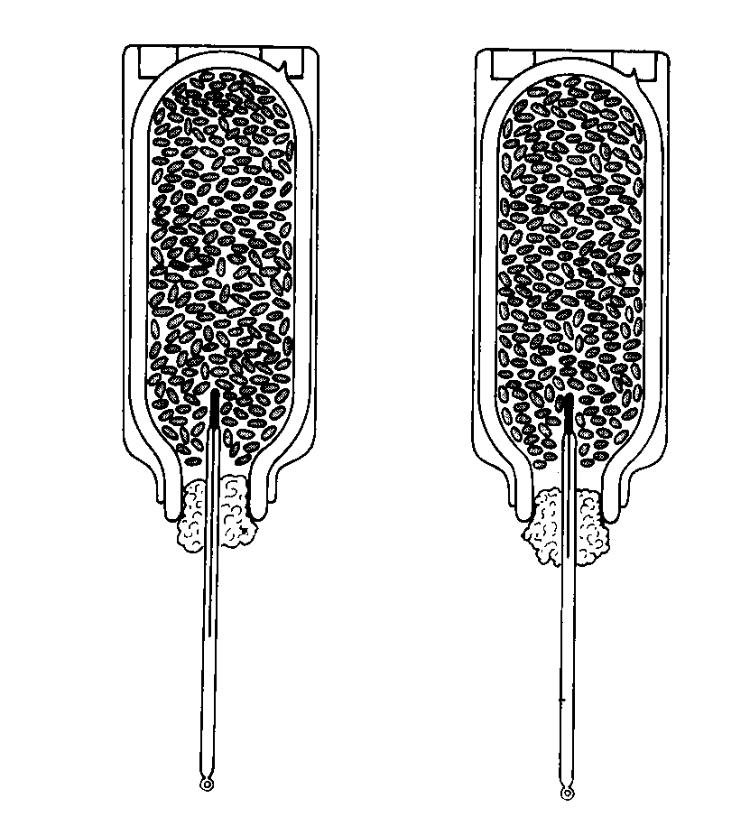

• describe simple controlled experiments to investigate the effect of light on net gas exchange from a leaf, using hydrogen-carbonate indicator. (pp115)

Tubes set up as follows:
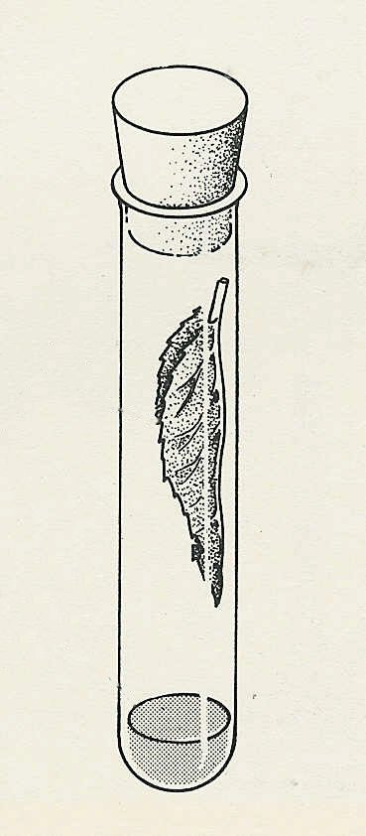
Light Dark Dim Light Control – no leaf

X

- 4 boiling tubes + 10cm³ hydrogen carbonate indicator
- 3 leaves from same plant; same size & health
- Control
- Seal with bung
- Leave for a few hours In different light conditions as shown
- Any CO₂ produced changes colour from red/orange to yellow - ?why
- Any CO₂ absorbed, colour changes to purple – why?
- Which does which?
- A variation could involve the use of water snails or, if not available, small land insects placed on a gauze platform above the indicator, with and without the water plant.

• describe a simple experiment to investigate the effect of exercise on breathing in humans. (p30)

- The breathing rate can be measured at rest and after a period of varying exercise by counting the number of inhalations per minute.
- Plot graph
- How should you choose the subject(s)?
- How long should each experiment last?
- Repetitions?
- What is meant by the recovery rate?

• describe experiments that investigate the role of environmental factors in determining the rate of transpiration from a leafy shoot. (pp130-131)

- A bubble potometer can be used to illustrate the effects of light, wind, temperature and air humidity.
- Plants covered with dark polythene bags simulate darkness and can be compared with plants covered with transparent polythene bags.
- Hair dryers can simulate wind.
- The use of potted plants is also acceptable, where the pot and the soil is sealed with polythene and the mass of the potted plant is measured before and after a period of exposure to the environmental factor.
- 2 different potometers are shown below

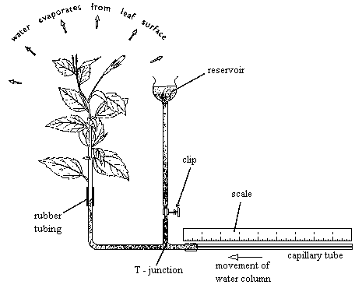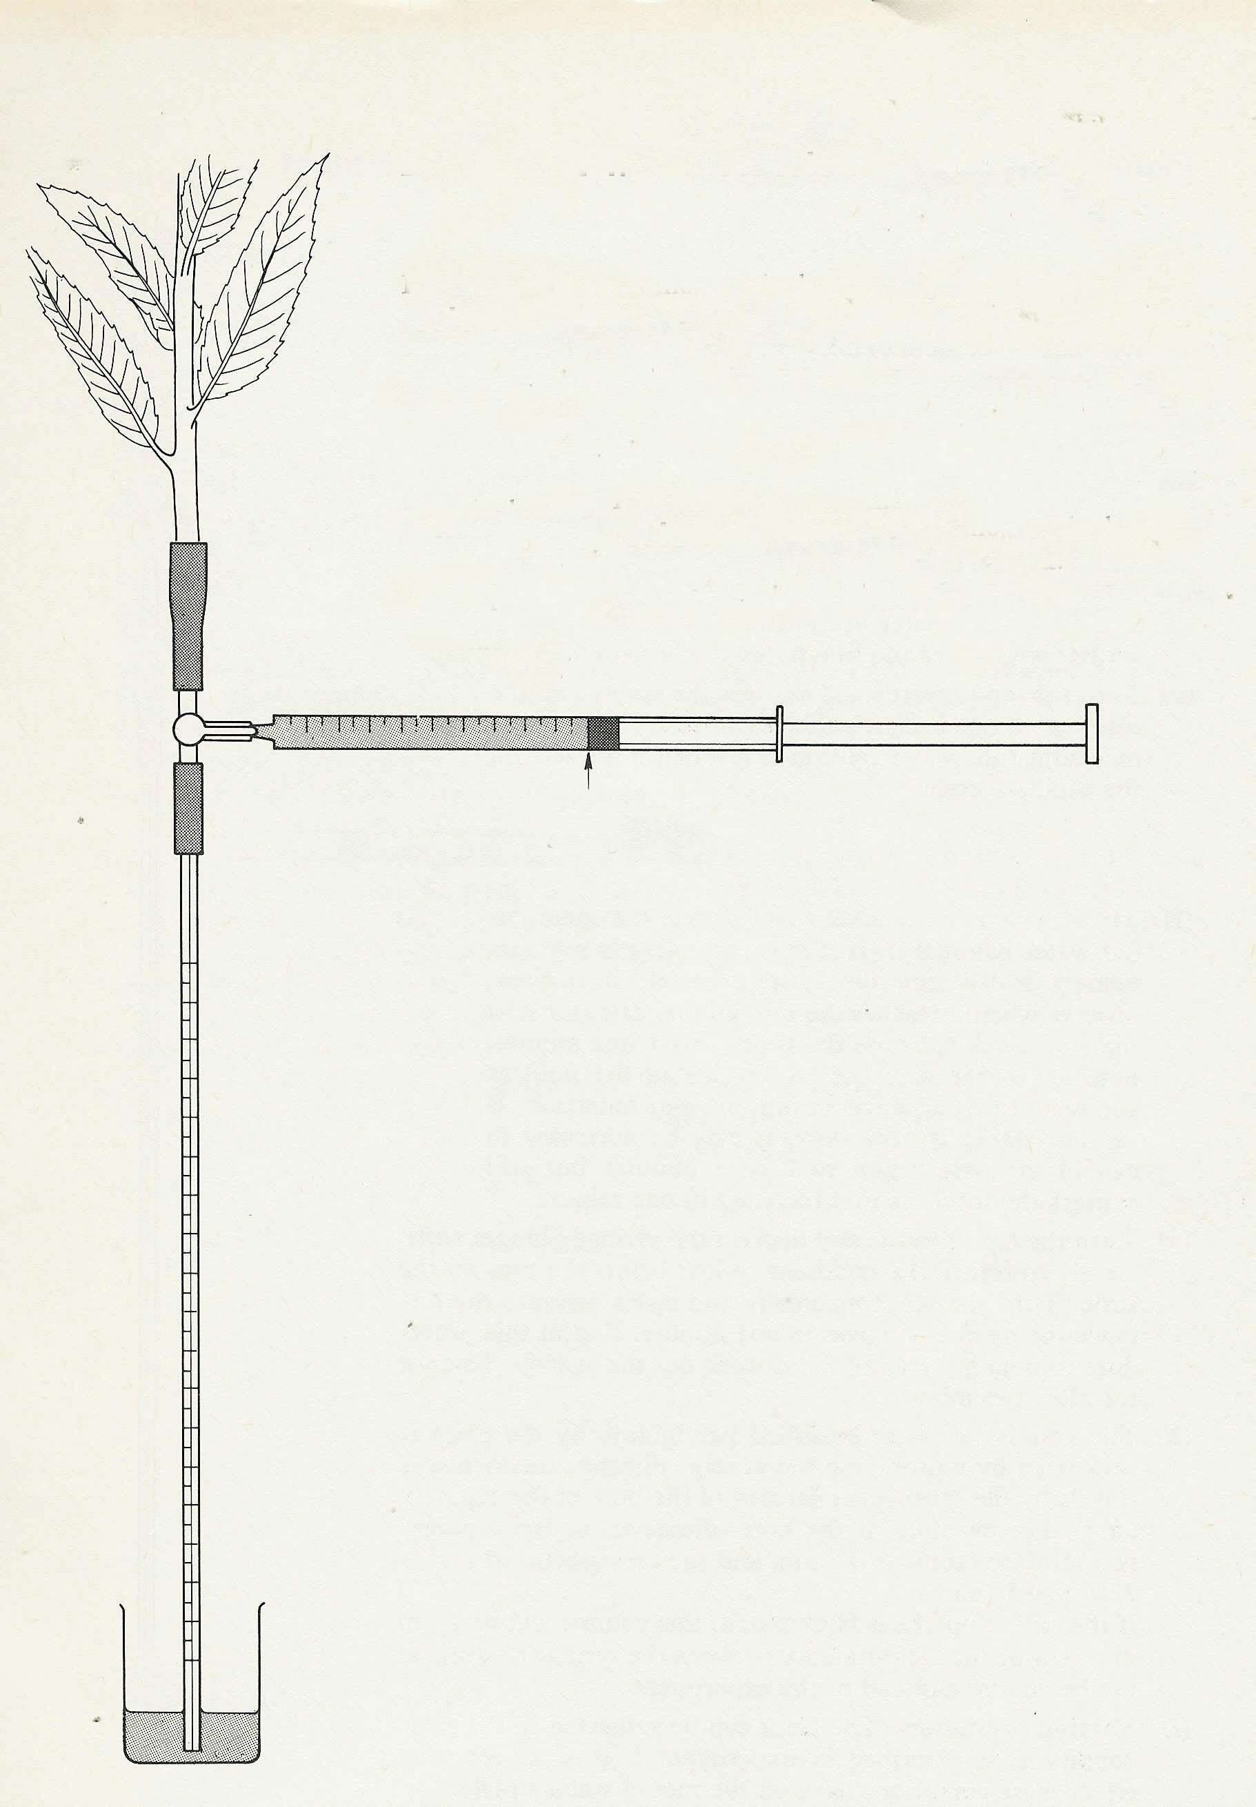

• recall controlled experiments to demonstrate phototropic and geotropic plant growth responses. (pp139-141)

- Plant seedlings, e.g. cress, can be used to demonstrate phototropism.
- Petri dishes containing moist cotton wool and the plant material can be put into light proof boxes such as shoe boxes.
- To create unidirectional light a small slit can be cut in one side of the box and light can be shone into the box.
- Control seedlings can either have aluminium caps put on their tips or can be kept in a shoe box without a slit for light.
- A klinostat needs to be used to demonstrate geotropism.

• recall the use of quadrats to estimate the population size of an organism in two different areas. (pp153&154)
- Select areas of 10m square using tape measures to form a grid.
- Generate 10 pairs of random numbers to act as coordinates. Why?
- Place quadrats at these coordinates.
- Quadrats can be used to sample part of the two areas.
- Calculate the population of the whole area.
- Repeat using different 10m square samples in other parts of the site.

• describe a simple experiment to investigate carbon dioxide production by yeast, in different conditions
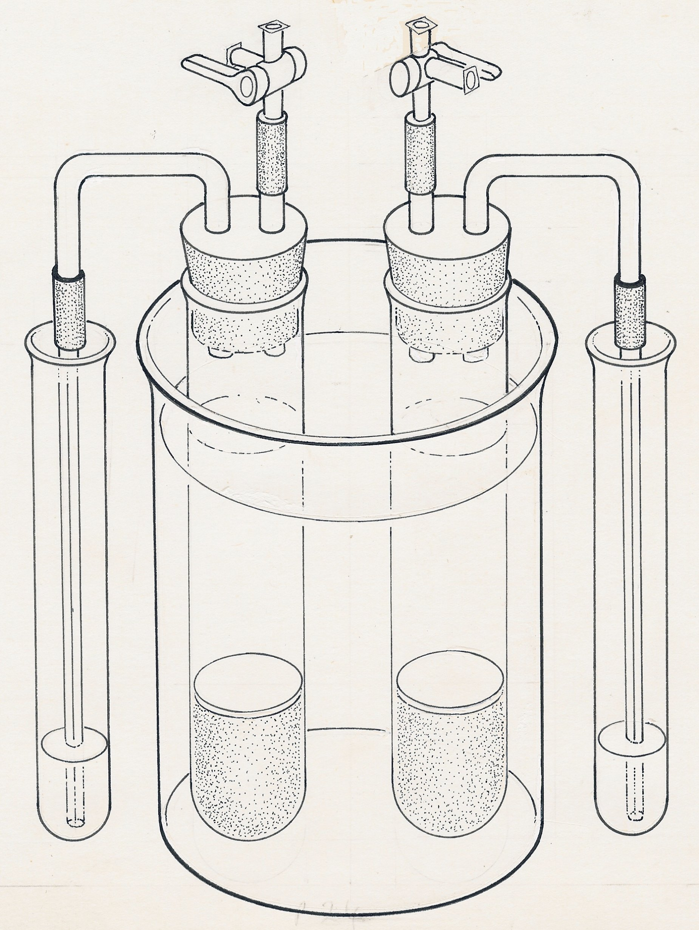
3-way tap
(open)
water bath
yeast and glucose A
lime water
thin layer of oil
tap open
tap closed
capillary tube
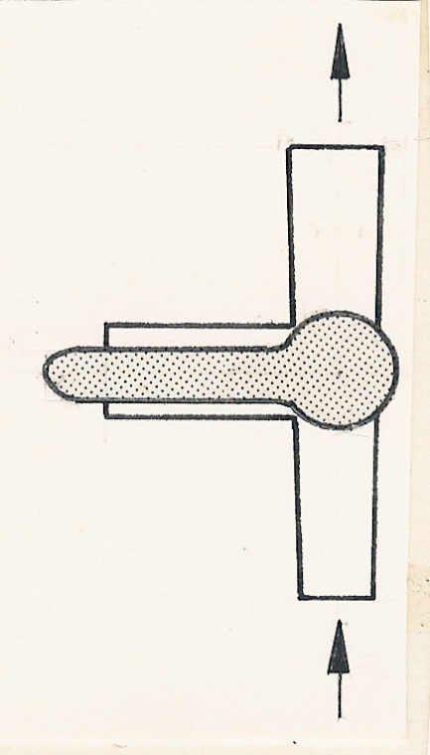
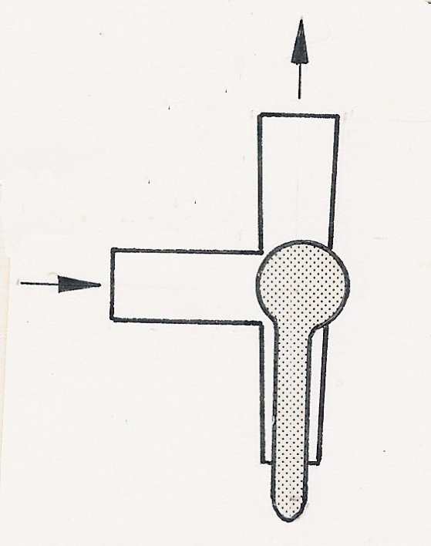
dead yeast and glucose B

- Boil some water to remove dissolved air.
- Dissolve some glucose in the water and transfer to 2 test tubes.
- Add a little live yeast to one test tube and dead yeast to another.
- Cover mixtures with a thin layer of oil
- Set up test tubes as above
- Rate of CO₂ bubbles can be determined.
- Lime water confirms gas is CO₂.
- Equipment can be modified to see the effects of changing glucose concentration, temperature and pH. How?

Other Experiments

A simple experiment to investigate the effect of exercise on heart rate in humans

- Measure and record pulse at rest.
- Then again after a short period of exercise, stepping on and off a low stool, or running up and down a flight of stairs for five minutes.
- The pulse rate should now be recorded until it returns to its rest level.
- The degree of exercise can be altered quantitatively. How?

A simple experiment to show how the sensitivity of the skin differs on finger tips, back of hand, wrist and forearm

- Using prongs of a hairpin 5mm apart
- Touch skin of blindfolded subject with one or both points.
- Record whether subject can tell whether it was 1 or 2 points.
- Repeat several times.
- This can be done on a number of normally exposed skin surfaces.

A practical exercise comparing floral structure in insect-pollinated and wind-pollinated flowers (p144 table)

